TRYHACKME LAB WRITEUP 04 / 04

Snort
  - Training-room summary and evidence-aware reflection

Training reference
https://tryhackme.com/room/snort

Learning objectives
- Explain rule direction, address/port matching and options.
- Recognize IDS alert-only operation.
- Connect the room themes to the separate Ubuntu lab where four custom rules were tested.

Concepts reviewed
Snort applies packet-level signature rules to identify traffic matching defined conditions.

Approach and SOC interpretation
- Identify which log or packet field directly supports a claim.
- Filter by event time and asset before drawing conclusions.
- Explain to a SOC analyst why the result could matter and how it may be validated.

Evidence and completion status
Learner reported completing this room; the supplied ZIP contains the room screenshot. Screenshot evidence is attached below.
TryHackMe screenshot is included; the separate Snort lab provides independently captured alert evidence.
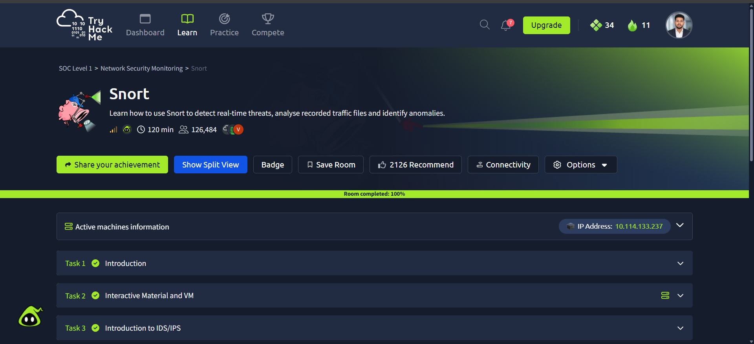
Evidence: source screenshot provided for Snort

Reflection / relation to the lab
This room connects to the Windows Sysmon, Linux auditd and Snort exercises documented in the Week 3 practical report. Specific room questions, answers and typed commands are intentionally not claimed without source evidence.

